***Assignment***

Print “Welcome to Javascript” in the browser window

Program:

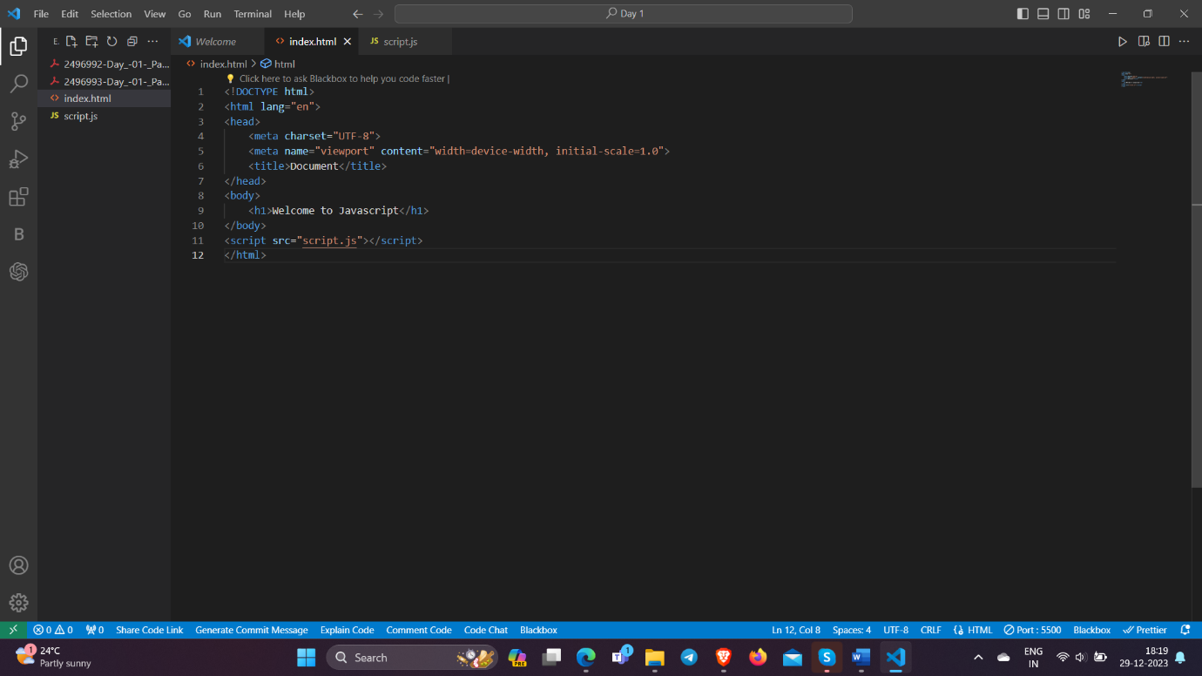

Output:

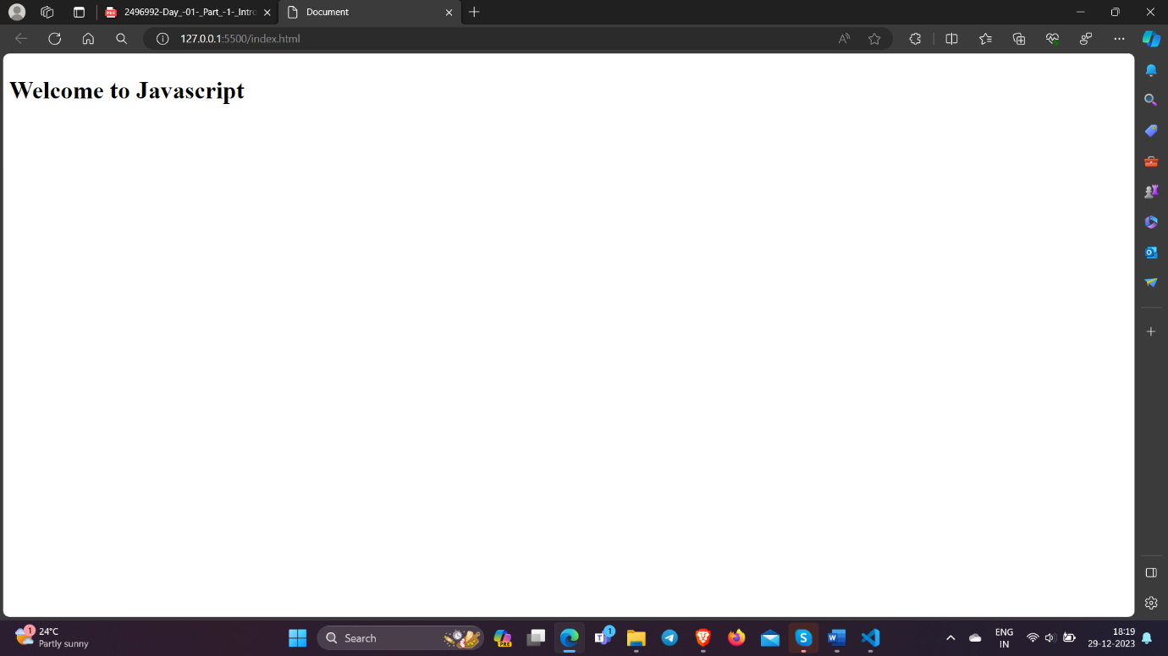

Print “I will learn Javascript” in the browser console window

Program:

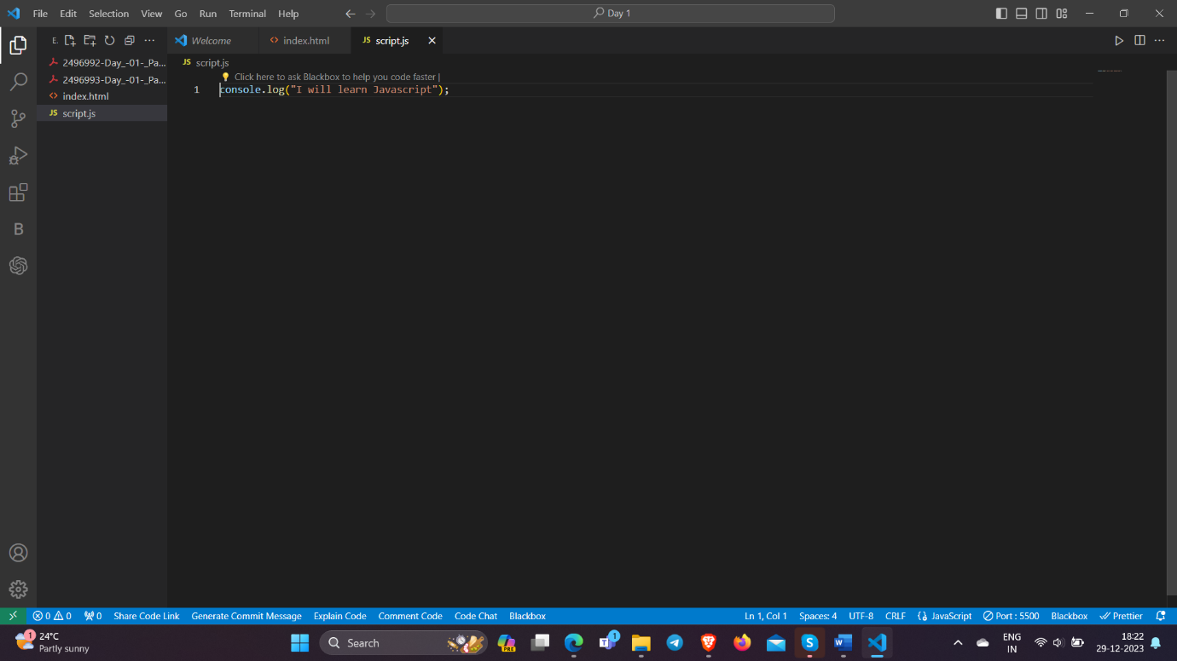

Output:

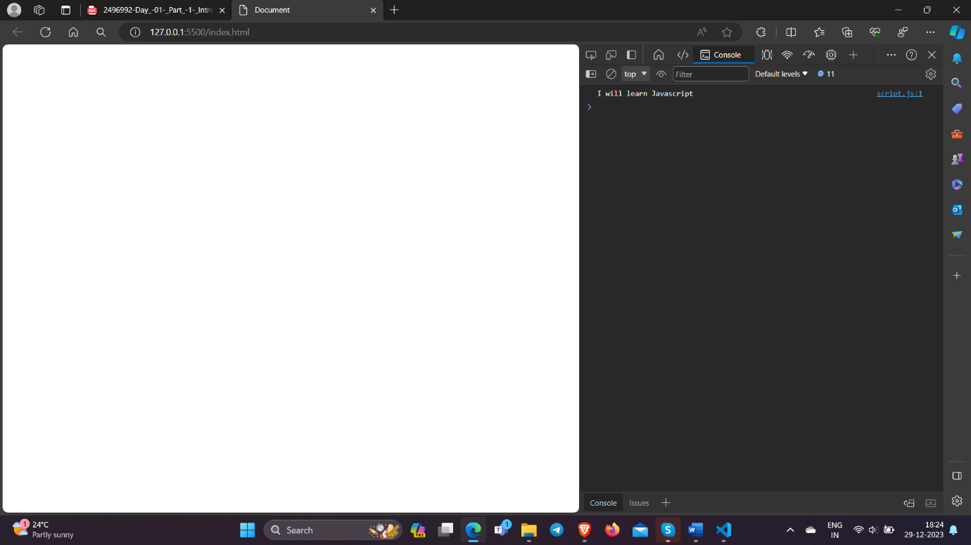

Print “Welcome to Primathon Academy” in the browser window

Program:

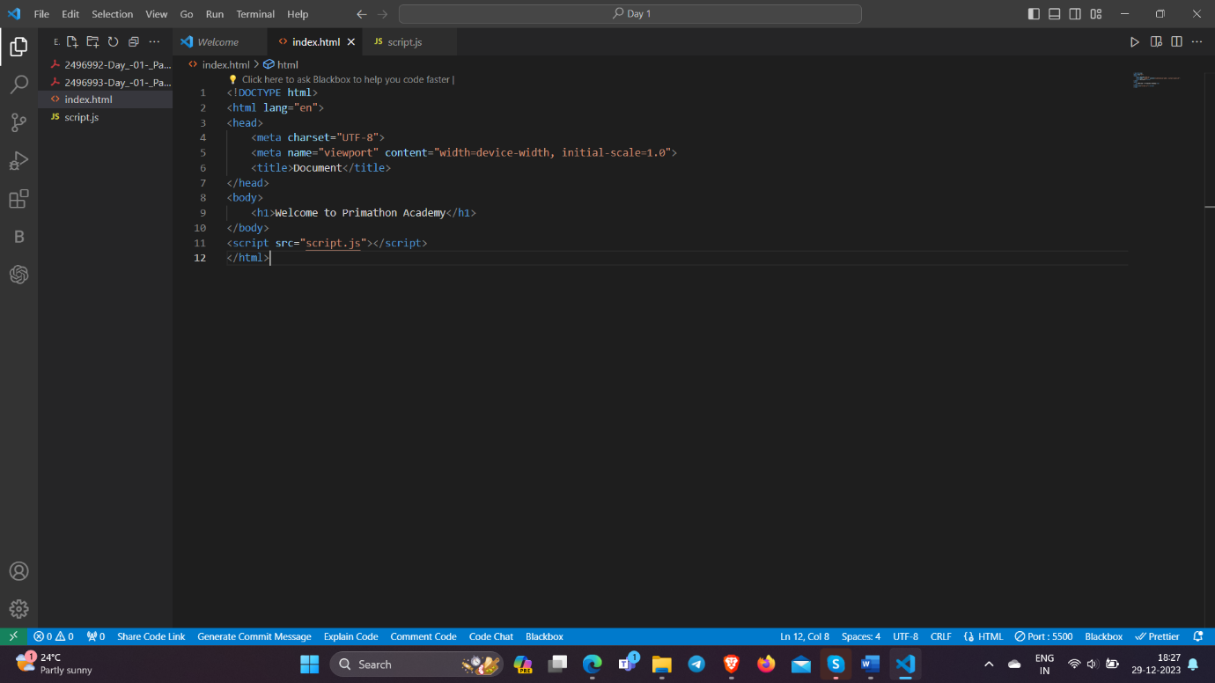

Output:

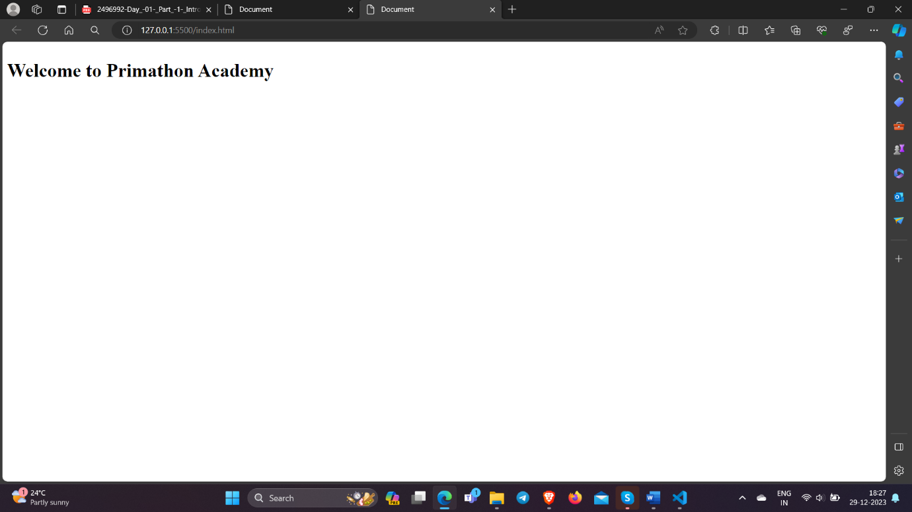

Print “I love Javascript” in the nodejs console

